**Software Testing Assignment  
Module–4(Database)**

1. **What is RDBMS?**

The software used to store, manage, query, and retrieve data stored in a relational database is called a relational database management system (RDBMS).

The RDBMS provides an interface between users and applications and the database, as well as administrative functions for managing data storage, access, and performance. Relational Database Management System (RDBMS) is a more advanced version of a DBMS system that allows access to data in a more efficient way. It is used to store or manage only the data that are in the form of tables.

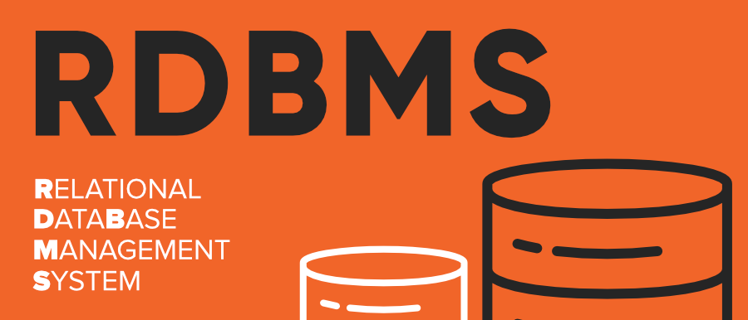

1. **What is SQL?**

SQL stands for Structured Query Language

SQL is a standard language for storing, manipulating and retrieving data in databases. SQL allows you to access and manipulate the databases. To use SQL in: MySQL, SQL Server, MS Access, Oracle, Sybase, Informix, Postgres, and other database systems.

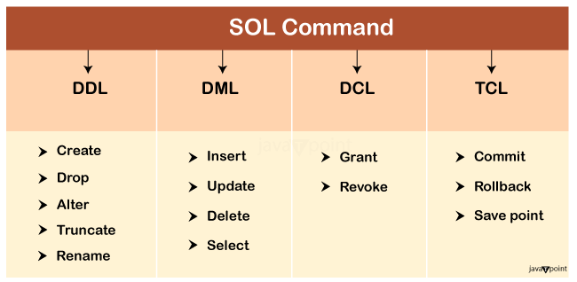

1. **Write SQL Commands**

|  |  |
| --- | --- |
| **INSERT** | Inserts new data into a database |
| INSERT INTO table_name (column_1, column_2, column_3)  VALUES (value_1, 'value_2', value_3); | |
| **SELECT** | Extracts data from a database |
| SELECT column_name  FROM table_name | |
| **UPDATE** | Updates data in a database |
| UPDATE table_name  SET some_column = some_value  WHERE some_column = some_value; | |
| **DELETE** | Deletes data from a database |
| DELETE FROM table_name  WHERE some_column = some_value; | |
| **CREATE DATABASE** | To create Database |
| CREATE DATABASE databasename; | |
| **ALTER TABLE** | To modify table |
| ALTER TABLE table_name  ADD column_name datatype; | |
| **DROP TABLE** | deletes a table |
| DROP TABLE table_name; | |
| **AND** | operator that combines two conditions |
| SELECT column_name(s)  FROM table_name  WHERE column_1 = value_1  AND column_2 = value_2; | |
| **AS** | allows you to rename a column or table |
| SELECT column_name AS 'Alias'  FROM table_name; | |
| **AVG()** | an aggregate function that returns the average value for a numeric column. |
| SELECT AVG(column_name)  FROM table_name; | |
| **BETWEEN** | used to filter the result set within a certain range |
| SELECT column_name(s)  FROM table_name  WHERE column_name BETWEEN value_1 AND value_2; | |
| **NULL** | operators used with the WHERE clause to test for empty values. |
| SELECT column_name(s)  FROM table_name  WHERE column_name IS NULL; | |
| **OR** | filters the result set to only include rows where either condition is true. |
| SELECT column_name  FROM table_name  WHERE column_name = value_1  OR column_name = value_2; | |
| **ORDER BY** | It indicates you want to sort the result set by a particular column |
| SELECT column_name  FROM table_name  ORDER BY column_name ASC | DESC; | |
| **INNER JOIN** | combine rows from different tables if the *join condition* is true |
| SELECT column_name(s)  FROM table_1  JOIN table_2  ON table_1.column_name = table_2.column_name; | |
| **OUTER JOIN** | It combine rows from different tables even if the join condition is not met. Every row in the left table is returned in the result set, and if the join condition is not met, then NULL values are used to fill in the columns from the right table. |
| **ROUND** | It rounds the values in the column to the number of decimal places specified by the integer. |
| SELECT ROUND(column_name, integer)  FROM table_name; | |
| **DISTINCT** | specifies that the statement is going to be a query that returns unique values in the specified column(s). |
| SELECT DISTINCT column_name  FROM table_name; | |
| **SUM** | A function that takes the name of a column as an argument and returns the sum of all the values in that column. |
| SELECT SUM(column_name)  FROM table_name; | |
| **WHERE** | It is a clause that indicates you want to filter the result set to include only rows where the following condition is true. |
| SELECT column_name(s)  FROM table_name  WHERE column_name operator value; | |
| **MIN()** | A function that takes the name of a column as an argument and returns the smallest value in that column. |
| SELECT MIN(column_name)  FROM table_name; | |
| **MAX()** | A function that takes the name of a column as an argument and returns the largest value in that column. |
| SELECT MAX(column_name)  FROM table_name; | |
| **LIMIT** | A clause that lets you specify the maximum number of rows the result set will have. |
| SELECT column_name(s)  FROM table_name  LIMIT number; | |
| **LIKE** | A special operator used with the WHERE clause to search for a specific pattern in a column. |
| SELECT column_name(s)  FROM table_name  WHERE column_name LIKE pattern; | |

1. **What is Join?**

A JOIN clause is used to combine rows from two or more tables, based on a related column between them. The join keyword merges two or more tables and creates a temporary image of the merged table. Then according to the conditions provided, it extracts the required data from the image table, and once data is fetched, the temporary image of the merged tables is dumped. There are different types of SQL JOIN as bellow,

1. **Writes types of Join**

* INNER JOIN: Returns records that have matching values in both tables
* LEFT OUTER JOIN: Returns all records from the left table, and the matched records from the right table
* RIGHT OUTER JOIN: Returns all records from the right table, and the matched records from the left table
* FULL OUTER JOIN: Returns all records when there is a match in either left or right table

1. **How many Constraint and describe itself**

* NOT NULL - Ensures that a column cannot have a NULL value
* UNIQUE - Ensures that all values in a column are different
* PRIMARY KEY - A combination of a NOT NULL and UNIQUE. Uniquely identifies each row in a table
* FOREIGN KEY - Prevents actions that would destroy links between tables
* CHECK - Ensures that the values in a column satisfies a specific condition
* DEFAULT - Sets a default value for a column if no value is specified
* CREATE INDEX - Used to create and retrieve data from the database very quickly

1. **Difference between DBMS and RDBMS**

|  |  |
| --- | --- |
| RDBMS | DBMS |
| * Data stored is in table format | * Data stored is in the file format |
| * Multiple data elements are accessible together | * Individual access of data elements |
| * Data in the form of a table are linked together | * No connection between data |
| * Support distributed database | * No support for distributed database |
| * Data is stored in a large amount | * Data stored is a small quantity |
| * RDBMS supports multiple users | * DBMS supports a single user |
| * The software and hardware requirements are higher | * The software and hardware requirements are low |
| * Example: Oracle, SQL Server. | * Example: XML, Microsoft Access. |

**8.What is an SQL alias?**

SQL aliases are used to give a table, or a column in a table, a temporary name. Aliases are often used to make column names more readable. An alias only exists for the duration of that query. An alias is created with the AS keyword.

**9. Write a query to create the table in Structured Query Language.**

CREATE table table name

(

Column1 datatype (size),

column2 datatype (size),

columnN datatype(size)

);

**10**. **Write a query to insert data into table.**

INSERT INTO table_name (column1, column2, column3, ...)

VALUES (value1, value2, value3, ...);

**11. Write a query to update data into table with validations.**

UPDATE table_name SET column1 = value1, column2 = value2,…

WHERE condition;

**12. Write a query to delete data from table with validations.**

DELETE FROM table_name WHERE condition;

**13. Write a query to insert new column in existing table.**

ALTER TABLE table_name

ADD column_name datatype;

**14.** **Write a query to drop table and database.**

DROP TABLE table_name;

**15. Write a query to find max and min value from table.**

SELECT MAX(column_name)

FROM table_name;

**16. What is API Testing?**

API is the mediator which helps to applications to communicate with each other. It is kind of logic written by developers using any programming language to perform something. Testing the business logic of any application is called API. QA will test the same logic and called API testing. API testing is a part of back-end testing like database.

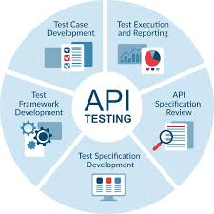

**17. Types of API Testing**

* **Open APIs:** These types of APIs are publicly available to use like OAuth APIs from Google. It has also not given any restriction to use them. So, they are also known as Public APIs.
* **Partner APIs**: Specific rights or licenses to access this type of API because they are not available to the public.
* **Internal APIs**: Internal or private. These APIs are developed by companies to use in their internal systems. It helps you to enhance the productivity of your teams.

**18. What is Responsive Testing?**

Responsive testing involves how a website or web application looks and behaves on different devices, screen sizes, and resolutions. The goal of responsive testing is to ensure that the website or web application can be used effectively on various devices, including desktops, laptops, tablets, and smartphones.



**19**. **Which types of tools are available for Responsive Testing?**

There are number of tools available which is as bellow,

* LT Browser
* Lembda Testing
* Google Resizer
* am I responsive
* Pixel tuner

**20. What is the full form of. ipa, .apk**

* **ipa:** iOS package App, international phonetic alphabet
* **apk:** Android Application Package

**21. How to create step for to open the developer option mode ON?**

**Step 1:** Go to Settings >my Phone.

**Step 2:** Tap Software Info > Build Number.

**Step 3:** Tap Build Number seven times. After the first few taps, you should see the steps counting down until you unlock the developer options. You may also have to tap in your PIN for verification.

**Step 4:** Once developer options are activated, you will see a message that reads, You are now a developer.

**Step 5:** Go back to the Settings pane, where you will now find Developer options as an entry.

**Step 6:** Tap it and toggle (USB debugging) the switch on if it is not already, and from there, you can proceed to make adjustments to your phone.

